**Supporting Document: 5.1.4**

**Mechanism for Submission of Students Grievances**

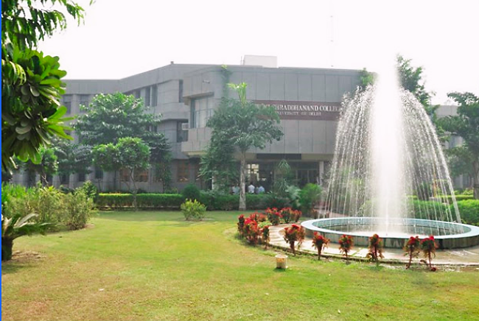

**Assessment Period: 2018-2023**

**GOVERNMENT SCHEMES**

|  |  |  |
| --- | --- | --- |
| S. No. | Content | Page No. |
| 1 | Prime Minister's Scholarship Scheme-PMSS | 2 - 7 |
| 2 | Delhi Government E-district | 8 - 10 |
| 3 | National Scholarship Portal -NSP | 11 - 26 |

